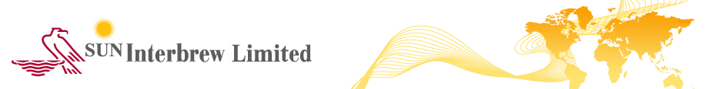

26.04.2017

LEFKOSIA, CYPRUS

ANNOUNCEMENT

Re: SUN Interbrew Plc - Approval and publication of the Annual Financial Report for the financial year ended 31 December 2016

The Board of Directors of SUN Interbrew Plc (the “Company”) has today approved the Annual Financial Report of the Company for the financial year that ended on 31 December 2016, which was prepared in accordance with the applicable provisions of the Transparency Requirements (Securities Admitted to Trading on a Regulated Market) Laws of 2007 to 2016 of the Republic of Cyprus. The Annual Financial Report includes the final, audited financial statements of the Group (consolidated) and of the Company (separate) for 2016, the Management Report and the Independent Auditors’ Report.

The Annual Financial Report is hereby attached. Further, it will be uploaded on the Company’s website (www.suninterbrew.com) from where it may be accessed and printed, and will be published and made available according to the applicable Transparency legislation and stock exchange rules.

SUN Interbrew Plc contact:

Denis Khrenov – Chief Executive Officer
Tel : +380 44 201 4087
Email: D.Khrenov@ab-inbev.com

NAP Regulatory Compliance Services Ltd
Regulatory Compliance Officer for the Company
Tel: +357 22 554 343
Fax: +357 22 554 455
Email: info@napcompliance.com

CC: Cyprus Securities and Exchange Commission

