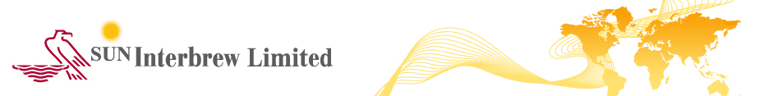

08.05.2014

Lefkosia, Cyprus

ANNOUNCEMENT

Re: 1. Approval by the Board of Directors of Sun Interbrew Plc Group (the “Group”) of the Consolidated Interim Management Statement of the Group, which is prepared and published during the first half of the financial year 2014.

2. Announcement of AGM

The Board of Directors of the Group of SUN Interbrew Plc (the “Company”) has today approved the Consolidated Interim Management Statement of the Group which is prepared and published during the first half of the financial year 2014, pursuant to the applicable provisions of the Transparency Requirements (Securities Admitted to Trading on a Regulated Market) Laws of 2007 to 2013, of the Republic of Cyprus.

The Interim Management Statement is attached, and will also be uploaded on the website of the Company (www.suninterbrew.com) from where it may be printed, and will be published and made available according to the applicable Transparency legislation and stock exchange rules.

2. Announcement of the AGM
The Board announces that the Annual General Meeting of the Shareholders of the Company will take place on the 4th of June, 2014, at 11:00 am, at the registered office of the Company at 1 Lampousas street, 1095, Nicosia. Cyprus. The shareholders will be notified pursuant to the applicable company legislation provisions.

NAP Regulatory Compliance Services Ltd
Regulatory Compliance Officer for the Company
Tel: +357 22 554 343
Fax: +357 22 554 455
Email: info@napcompliance.com
CC: Cyprus Securities and Exchange Commission
UNAUDITED INTERIM MANAGEMENT STATEMENT
FOR THE PERIOD 1 JANUARY TO 08 MAY 2014

The Board of Directors of the Group of Sun Interbrew Plc (the “Company”) presents the approved Interim Management Statement of the Company and its subsidiary companies (together referred to as the “Group”) which is published during the first semester of the financial year 2014 and covers the period from the commencement of the first semester of 2014 until today and which has not been audited by the external auditors of the Group.

Main activities
The principal activities of the Group, which remain the same from last year, are manufacturing, marketing and distribution of beer and soft drinks.

Significant events and transactions

On 26 March 2014, the Group announced the closure of its brewery in Perm. The Management is currently in the process of evaluating various alternatives with respect to the plant assets.
On 16 April 2014 the Group lost a case with the tax authorities in the Moscow Federal Arbitration Court relating to a legal dispute on deductibility of certain royalty expenses paid for know-how charges. The Group plans to remit the amount owed of EUR 6,169 thousands within the next three months from the court date and then appeal the decision at the Supreme Court.

General Description of the financial position and performance of the Group

Results for the first quarter ended 31 March, 2014
The Results of the Group in the above period, as compared to those of the corresponding period in the last year, show a decrease in total net revenues. The total cost of sales showed decrease as compared to the corresponding period in the last year. Losses in the relevant period remain at the same levels as those of the corresponding period in the last year.

It is noted that, the fixed costs of the Group in the first quarter 2014 show a continuous reduction as compared to those in the corresponding period in the last year, mainly due to organization structure optimization and application of strict cost saving policies.

Beer volumes in Russia and Ukraine declined by 10.9% in 1Q14.

In Russia, our beer volumes declined by 10.4% in 1Q14, driven by industry weakness following regulatory changes, and market share loss in the value segment in line with our premiumization strategy.

In Ukraine, our beer volumes declined by 14.3% in 1Q14, with the political instability in the country significantly impacting beer consumption.

There has been no material differentiation in the above results of the Group since the end of the First Quarter 2014, until today.

The Group’s Management continues to monitor the situation and undertakes all possible measures to eliminate possible financial risks. The Management believes that the current liquidity position allows to consider the Group as going concern.

Lefkosia, 08 May 2014.

SUN Interbrew Plc contact:

Anton Chvanov – Tax and Control Director
Tel : + 7 (495) 960 23 60
Anton.Chvanov@inbev.com

